From: https://medium.com/the-new-york-times/the-tech-cold-wars-most-complicated-machine-that-s-out-of-china-s-reach-6d6a9e6dce1

The Tech Cold War’s ‘Most Complicated Machine’ That’s Out of China’s Reach
  - A $150 million chip-making tool from a Dutch company has become a lever in the U.S.-Chinese struggle. It also shows how entrenched the global supply chain is.
The New York Times

18 hours ago·[20210706] 6 min read
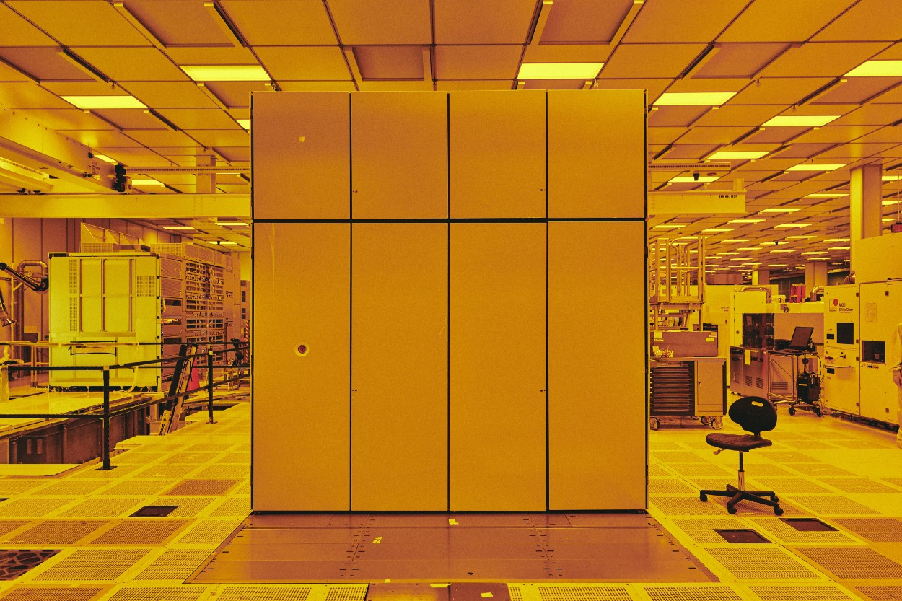
A machine made by a Dutch company, ASML, produces much tinier circuitry on computer chips.
This one is in an IBM facility in Albany, N.Y.
Photo: Bryan Derballa for The New York Times
By Don Clark
SAN FRANCISCO — President Joe Biden and many lawmakers in Washington are worried these days about computer chips and China’s ambitions with the foundational technology.
But a massive machine sold by a Dutch company has emerged as a key lever for policymakers — and illustrates how any country’s hopes of building a completely self-sufficient supply chain in semiconductor technology are unrealistic.
The machine is made by ASML Holding, based in Veldhoven. Its system uses a different kind of light to define ultrasmall circuitry on chips, packing more performance into the small slices of silicon. The tool, which took decades to develop and was introduced for high-volume manufacturing in 2017, costs more than $150 million. Shipping it to customers requires 40 shipping containers, 20 trucks and three Boeing 747s.
The complex machine is widely acknowledged as necessary for making the most advanced chips, an ability with geopolitical implications. The Trump administration successfully lobbied the Dutch government to block shipments of such a machine to China in 2019, and the Biden administration has shown no signs of reversing that stance.
Manufacturers can’t produce leading-edge chips without the system, and “it is only made by the Dutch firm ASML,” said Will Hunt, a research analyst at Georgetown University’s Center for Security and Emerging Technology, which has concluded that it would take China at least a decade to build its own similar equipment. “From China’s perspective, that is a frustrating thing.”
A silicon wafer at IBM full of microchips made with the machine, which costs more than $150 million. Photo: Bryan Derballa for The New York Times
ASML’s machine has effectively [been] turned [by the Anglo-American Establishment] into a chokepoint in the supply chain for chips, which act as the brains of computers and other digital devices. The tool’s three-continent development and production — using expertise and parts from Japan, the United States and Germany — is also a reminder of just how global that supply chain is, providing a reality check for any country [other than the USA] that wants to leap ahead in semiconductors by itself.
That includes not only China but [sorta] the United States, where Congress is debating plans to spend more than $50 billion to reduce reliance on foreign chip manufacturers. Many branches of the federal government, particularly the Pentagon, have been worried about the U.S. dependence on Taiwan’s leading chip manufacturer and the island’s proximity to China.
A study this past spring by Boston Consulting Group and the Semiconductor Industry Association estimated that creating a self-sufficient chip-supply chain would take at least $1 trillion and sharply increase prices for chips and products made with them.
That goal is “completely unrealistic” for anybody, said Willy Shih, a management professor at Harvard Business School who studies supply chains. ASML’s technology “is a great example of why you have global trade.”
The situation underscores the crucial role played by ASML, a once-obscure company whose market value now exceeds $285 billion. It is “the most important company you never heard of,” said C.J. Muse, an analyst at Evercore ISI.
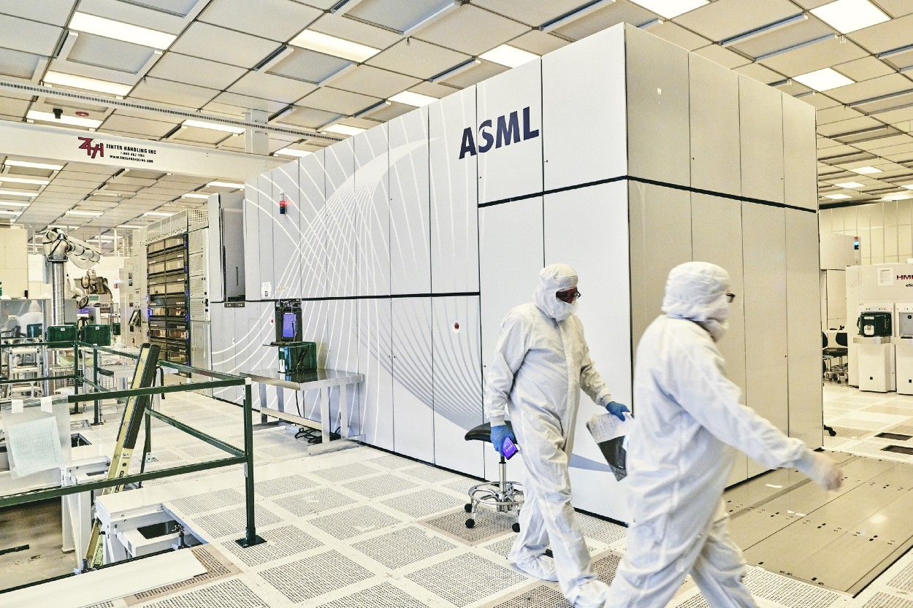
The machine requires 40 shipping containers, 20 trucks and three Boeing 747s to be shipped. Photo: Bryan Derballa for The New York Times
Created in 1984 by electronics giant Philips and another toolmaker, Advanced Semiconductor Materials International, ASML became an independent company and by far the biggest supplier of chip-manufacturing equipment that involves a process called lithography.
Using lithography, manufacturers repeatedly project patterns of chip circuitry onto silicon wafers. The more tiny transistors and other components that can be added to an individual chip, the more powerful it becomes and the more data it can store. The pace of that miniaturization is known as Moore’s Law, named after Gordon Moore, a co-founder of chip giant Intel.
In 1997, ASML began studying a shift to using extreme ultraviolet, or EUV, light. Such light has ultrasmall wavelengths that can create much tinier circuitry than is possible with conventional lithography. The company later decided to make machines based on the technology, an effort that has cost $8 billion since the late 1990s.
The development process quickly went global. ASML now assembles the advanced machines using mirrors from Germany and hardware developed in San Diego that generates light by blasting tin droplets with a laser. Key chemicals and components come from Japan.
ASML CEO Peter Wennink said a lack of money in the company’s early years had led it to integrate inventions from specialty suppliers, creating what he calls a “collaborative knowledge network” that innovates quickly.

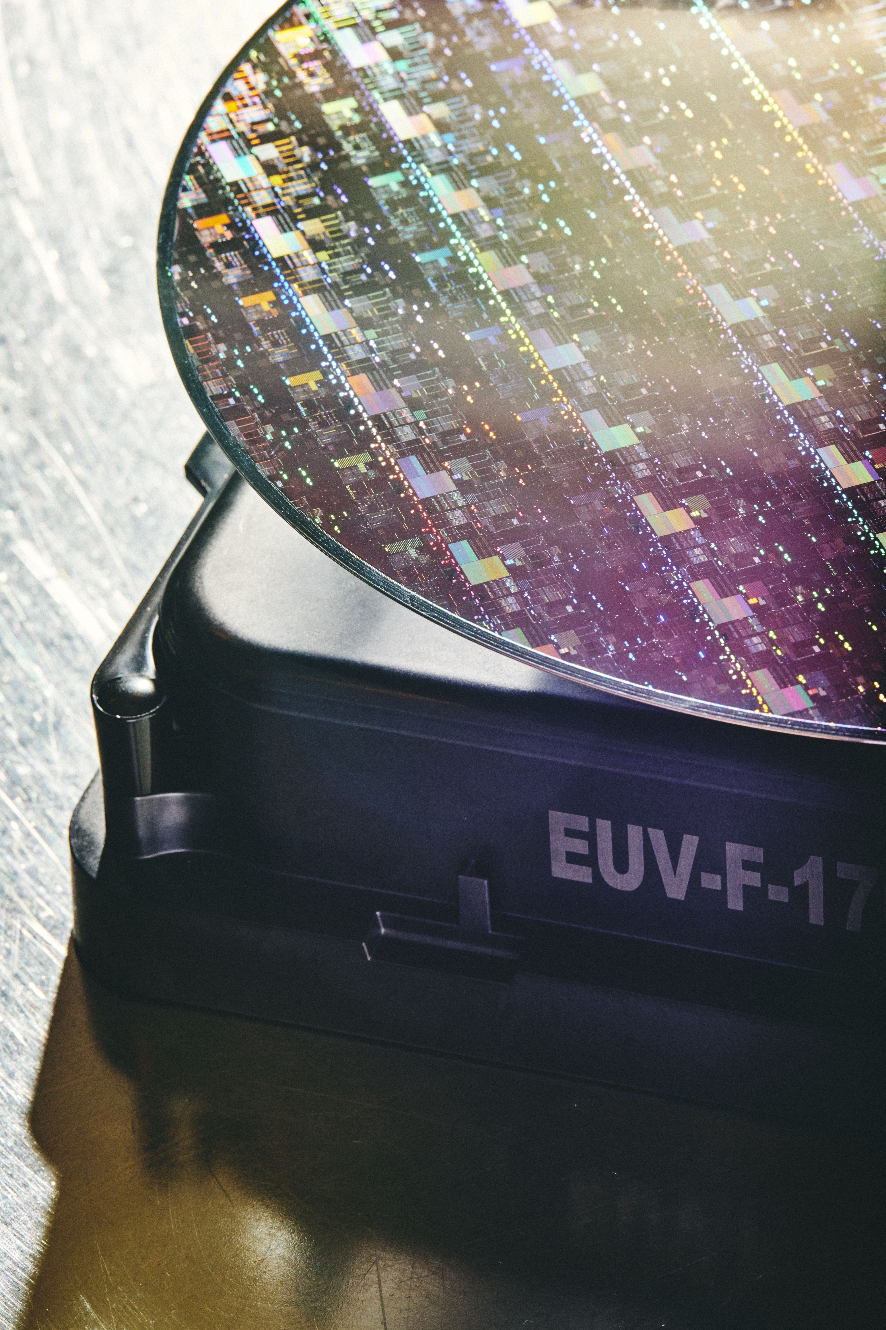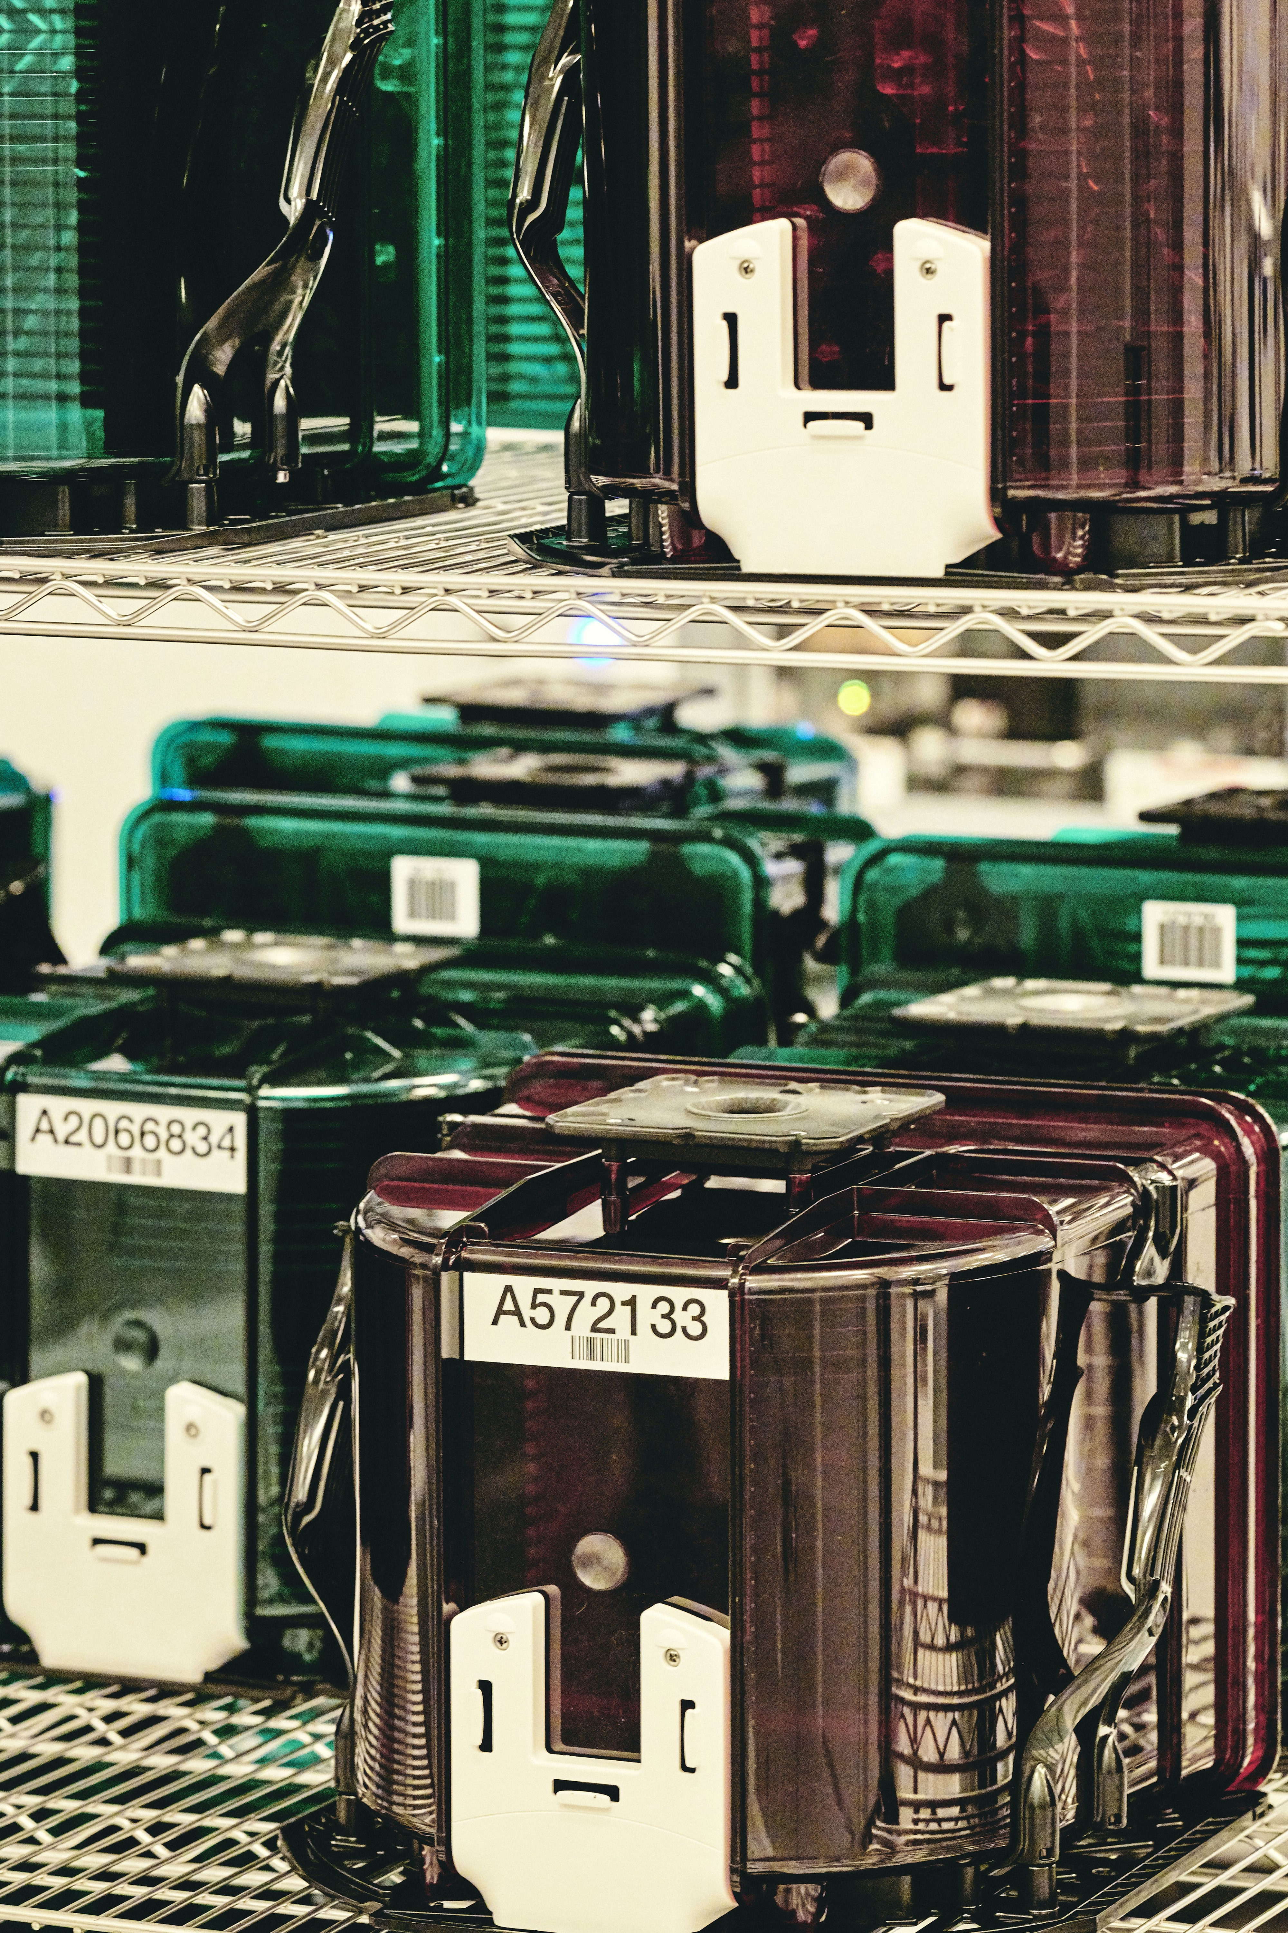
(L) EUV stands for extreme ultraviolet light, which produces the circuitry. (R) A rack carrying silicon wafers that run through the machine.
Photos: Bryan Derballa for The New York Times
“We were forced to not do ourselves what other people do better,” he said.
ASML built on other international cooperation. In the early 1980s, researchers in the United States, Japan and Europe began considering the radical shift in light sources. The concept was taken up by a consortium that included Intel and two other U.S. chipmakers, as well as Department of Energy labs.
ASML joined in 1999 after more than a year of negotiations, said Martin van den Brink, ASML’s president and chief technology officer. Other partners of the company included the Imec research center in Belgium and another U.S. consortium, Sematech. ASML later attracted big investments from Intel, Samsung Electronics and Taiwan Semiconductor Manufacturing Company to help fund development.
That development was made trickier by the quirks of EUV light. Lithography machines usually focus light through lenses to project circuit patterns on wafers. But the small EUV wavelengths are absorbed by glass, so lenses won’t work. Mirrors, another common tool to direct light, have the same problem. That meant the new lithography required mirrors with complex coatings that combined to better reflect the small wavelengths.
So, ASML turned to Zeiss Group, a 175-year-old German optics company and longtime partner. Its contributions included a 2-ton projection system to handle EUV light, with six specially shaped mirrors that are ground, polished and coated over several months in an elaborate robotic process that uses ion beams to remove defects.
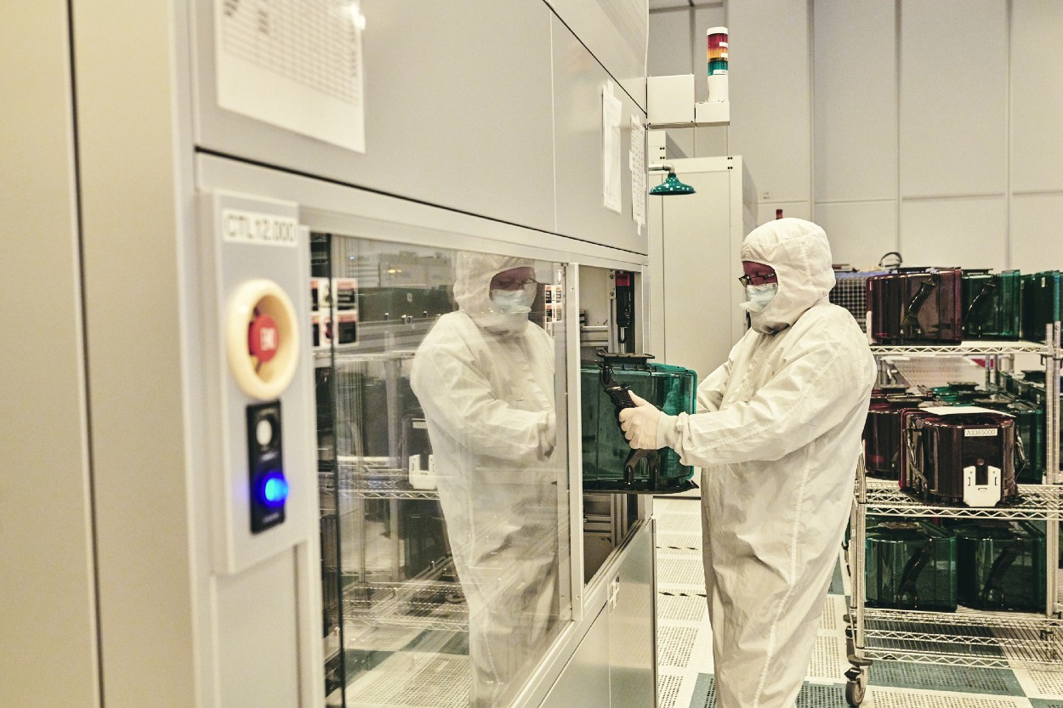
“It’s definitely the most complicated machine humans have built,” an IBM executive said.
Photo: Bryan Derballa for The New York Times
Generating sufficient light to project images quickly also caused delays, van den Brink said. But Cymer, a San Diego company that ASML bought in 2013, eventually improved a system that directs pulses from a high-powered laser to hit droplets of tin 50,000 times a second — once to flatten them and a second time to vaporize them — to create intense light.
The new system also required redesigned components called photomasks, which act like stencils in projecting circuit designs, as well as new chemicals deposited on wafers that generate those images when exposed to light. Japanese companies now supply most of those products.
Since ASML introduced its commercial EUV model in 2017, customers have bought about 100 of them. Buyers include Samsung and TSMC, the biggest service producing chips designed by other companies. TSMC uses the tool to make the processors designed by Apple for its latest iPhones. Intel and IBM have said EUV is crucial to their plans.
“It’s definitely the most complicated machine humans have built,” said Darío Gil, a senior vice president at IBM.
Dutch restrictions on exporting such machines to China, which have been enforced since 2019, haven’t had much financial impact on ASML since it has a backlog of orders from other countries. But about 15% of the company’s sales come from selling older systems in China.
In a final report to Congress and Biden in March, the National Security Commission on Artificial Intelligence proposed extending export controls to some other advanced ASML machines as well. The group, funded by Congress, seeks to limit artificial intelligence advances with military applications.
Hunt and other policy experts argued that since China was already using those machines, blocking additional sales would hurt ASML without much strategic benefit. So does the company.
“I hope common sense will prevail,” van den Brink said.
For more great stories, subscribe to The New York Times.
© 2021 New York Times News Service

